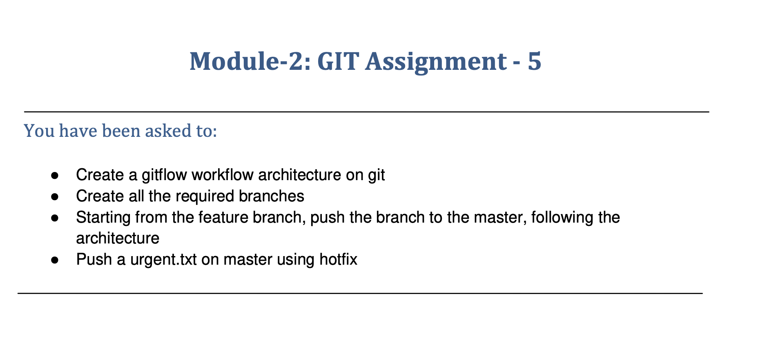

You have been asked to:

* ●  Create a gitflow workflow architecture on git
* ●  Create all the required branches
* ●  Starting from the feature branch, push the branch to the master, following the

architecture

* ●  Push a urgent.txt on master using hotfix

